Dear Contributor of ICEP 2022,

The authors are strongly recommended to use the attached abstract template in order to help fair evaluation by Technical Program Committee.

The abstract must not be longer than 2 pages, including about 1 page of text and 1 page of supporting figures and tables.

Figures and tables are not mandatory but will contribute to positive consideration and comments of the reviewers.

The submitted abstract will be used only for the reviewing and categorizing purposes and will not be transferred to the conference proceedings.

Once the abstract is accepted to regular or on-line poster presentations, the authors will be requested to submit a 2-pages final paper in double-column format by MARCH 7th, 2022, with copyright transfer to JIEP. The paper format is available on the conference homepage.

Your cooperation is highly appreciated!

Sincerely yours,
ICEP 2022 Organizing Committee

(Please erase this page on submission)

Abstract Template (erase this line before submission)

Place Your Title Here
Author A, Author B*,….Author N⁺
*Department, Institution/Company, Town, State/Country, Email-Address
⁺Department, Institution/Company, Town, State/Country

Summary
In a single paragraph, state what is the technical problem you addressed, the approach you took, and major findings or achievements, and conclusion clearly and simply. The degree of novelty in your technical approach is a major component of the evaluation criteria used in the selection process. You are strongly discouraged from submitting work that has already been presented at a conference or has already been published elsewhere.

List of Keywords: list 3 – 5 keywords of your work; separate them by semicolon.

I. Introduction and Motivation
In this section, briefly describe the background of your work and the problem to be solved. Your description should help the reviewers to evaluate the significance of the problem. Cite references using footnote. You may use a figure to illustrate basic structures, device designs, etc. This section should be no more than half of a page.

II. Technical Approach or Experimental Procedure

Clearly describe your technical approach, scientific basis, and tasks you undertook to solve the problem identified in the previous section. You may use a figure or a table to illustrate your experimental procedure, test setup, etc. This section should not be more than half of a page.
III. Results and Discussion
It is important to present preliminary results you have already obtained in the abstract. Use 1 to 2 figures or tables to illustrate your findings. Do not include expected results. You may place all your figures and tables on the second page.

Figures: Up to 6 figures and tables are accepted.

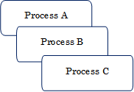
Fig. 1: Give clear and brief description on the figures and tables. Captions should be written so that the readers can understand the contents without going into the mainbody.
Fig. 2: Photos must be presented with definitely visible resolution and contrast.
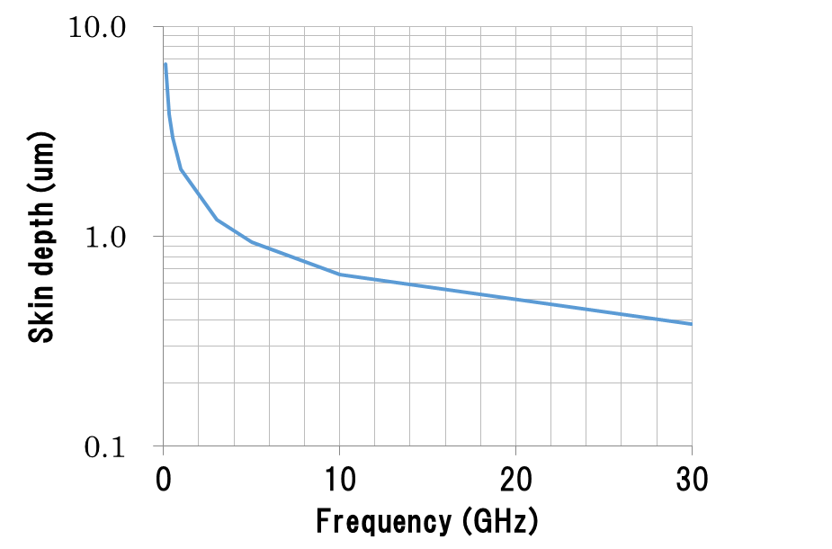
Fig. 3: Graphs and drawings must be sufficiently thick in readability.

J. K. Author, “Title of paper,” in Unabbreviated Name of Conf., year, pp. xxx-xxx.

