Dear Contributor of ICEP-IAAC 2018,

In an effort to improve the conference quality, we would like to ask you to prepare an abstract using the attached template to help us better evaluate your submission. The abstract should contain about 1 page of text and 1 page for supporting figures and tables, with a total length of 2 pages at maximum.
Figures and tables to support the point of the paper will receive positive considerations.
Technical experts assigned by the conference technical committee will review your abstract, and their comments will be used in the selection process.
Your abstract will be used for review purpose only and will not be included in the conference proceeding.

Thank you very much for your contribution!

ICEP-IAAC2018 Organizing Committee

Abstract Template and Suggestions for its Content

Place Your Title Here
Author A, Author B*,….Author N⁺
*Department, Institution/Company, Town, State/Country, Email-Address
⁺Department, Institution/Company, Town, State/Country

Summary
In a single paragraph of less than 150 words, clearly state what is the technical problem you addressed, the approach you took, and major findings or achievements, and conclusion. The degree of novelty in your technical approach is a major component of the evaluation criteria used in the selection process. You are strongly discouraged from submitting work that has already been presented at a conference or has already been published elsewhere.

List of Keywords: list 3 – 5 keywords of your work; separate them by semicolon.

I. Introduction and Motivation
In this section, briefly describe the background of your work and the problem to be solved. Your description should help the reviewers to evaluate the significance of the problem. Cite references using footnote. You may use a figure to illustrate basic structures, device designs, etc. This section should be no more than half of a page.

II. Technical Approach or Experimental Procedure

Clearly describe your technical approach, scientific basis, and tasks you undertook to solve the problem identified in the previous section. You may use a figure or a table to illustrate your experimental procedure, test setup, etc. This section should not be more than half of a page.
III. Results and Discussion
It is important to present preliminary results you have already obtained in the abstract. Use 1 to 2 figures or tables to illustrate your findings. Do not include expected results. You may place all your figures and tables on the second page.

Figures
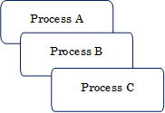
Fig. 1: Briefly describe figure contents, preferably self-explanatory.
Fig. 2: When using photos, make sure the resolution is sufficient.
Fig. 3: You may include up to six figures on the second page.

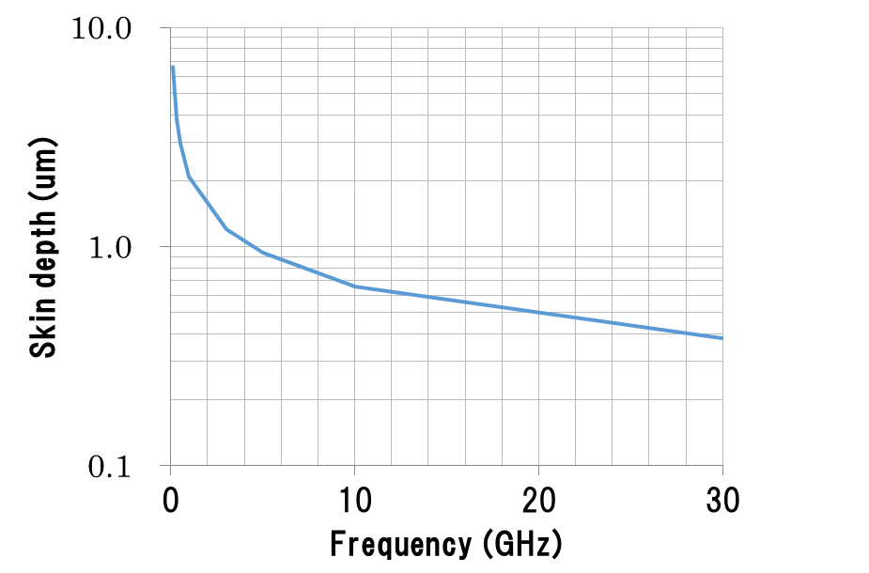
Be sure to use sufficiently thick linewidths in your drawings.

J. K. Author, “Title of paper,” in Unabbreviated Name of Conf., year, pp. xxx-xxx.

